DOLLARS 4 PNG SCHOLARS

The Virginia Synod invites you and your congregation to make a Special Offering in December to raise money for School Fees for the Children of our Partner Papua New Guinea Pastors.

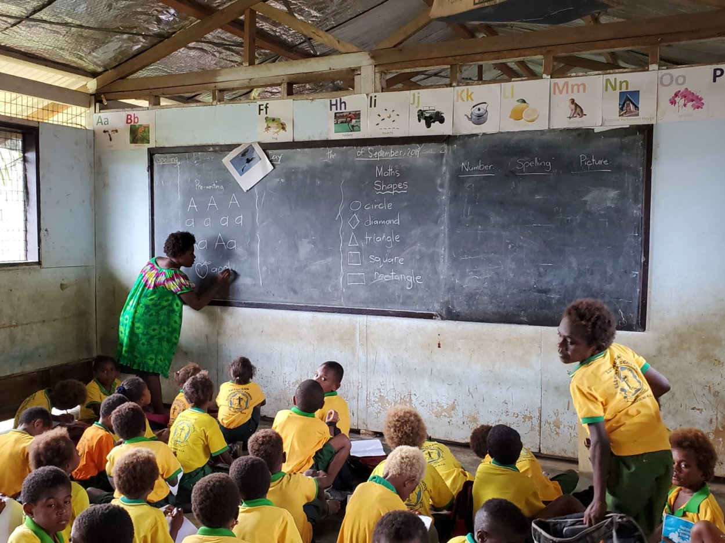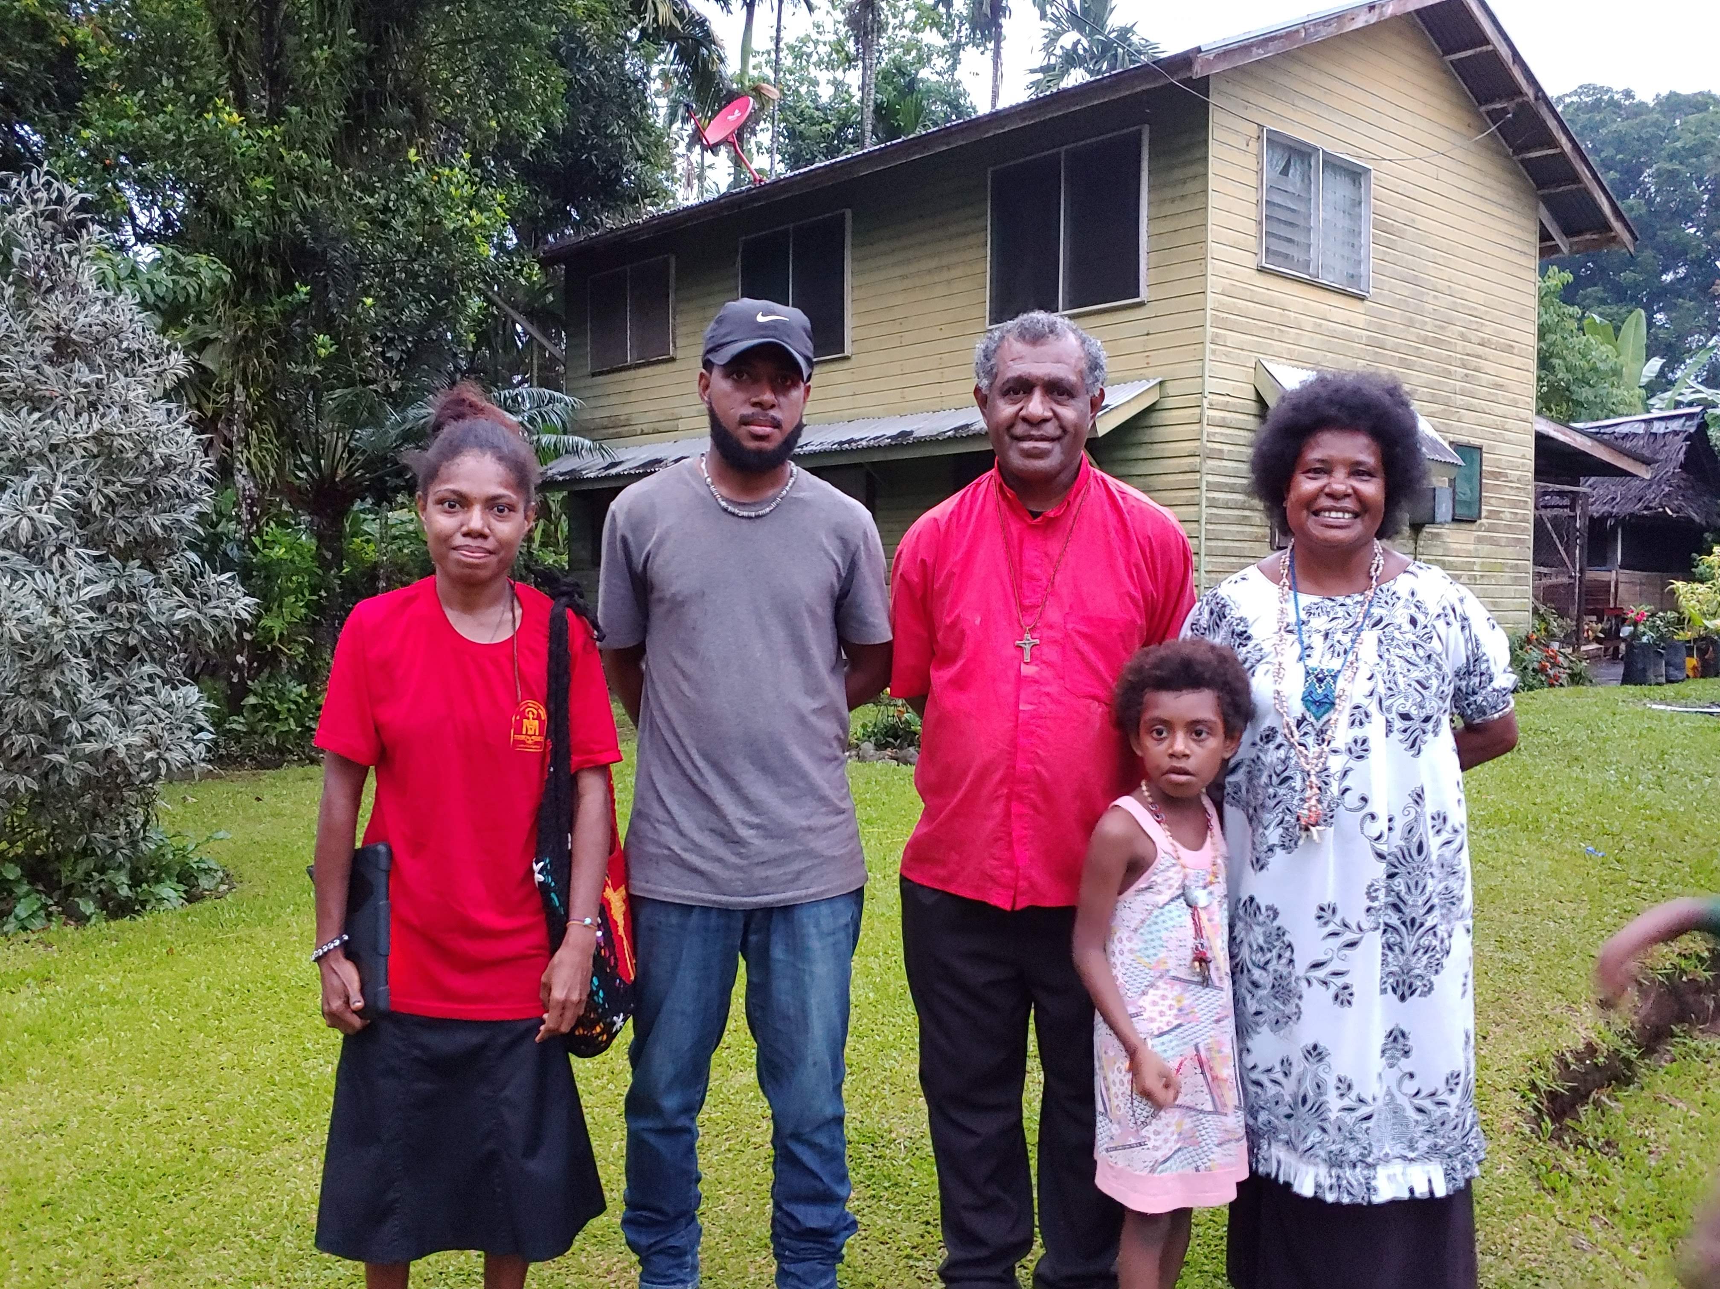

The Synod has supported this project for many years and needs your help. Pastors in PNG are not paid a salary and are dependent on their children during their retirement. This program enables Pastors to send their children to school without worrying about how to fund the annual school fees. This project has also paid the tuition for Seminarians from the New Guinea Islands District. Graduates have then returned to the NGI District to serve as pastors. What an amazing way to help spread the Gospel! We have set a goal of raising $15,000/year (only $100/congregation!) to help make this program sustainable. Consider contributing today!

Annual Fees:

$50 – Elementary Student (< $1 / week)*
$100 – Primary School Student (< $2 / week)*
$300 – Secondary School Student ($25 / month)*
$500 – College Student
$500 – Seminary Student

Checks sent to: VA Synod Dollars 4 Scholars, PO Box 70, Salem, VA 24153

*Recurring payments can be setup through the Synod website
(listed as “Papua New Guinea Scholarship” on the “Give” Page)

